NanoScience – NanoTechnology / NST

ID Student: Activity 2

NST & alternative energy sources

Part A

1) What potentialities and what problems does the exploitation of fossil fuels have?

It is estimated that global energy consumption will grow 44% from 2006 to 2030 (Khan & Arsalan 2016). While global energy consumption in 2000 was 13TW, it is estimated that it will grow to 28TW in 2050 (Hagfeldt et al. 2010). However, despite the elimination of fossil fuels and the large impact that they have on ecological footprint, using alternative energy sources is still not commonplace for many applications. Particularly, photovoltaic technologies signified only 0,04% of the fuel share of world’s total primary energy supply in 2007 (International Energy Agency 2007 in Pathakoti et al. 2018).

Current state:
- Albeit the elimination of fossil fuels & large impact on ecological footprint, using alternative energy sources is still not commonplace for many applications.
- Photovoltaic technologies: only 0,04% of the fuel share of the world’s total primary energy supply in 2007 (International Energy Agency 2007 in Pathakoti et al. 2018) and ~2% in 2017.
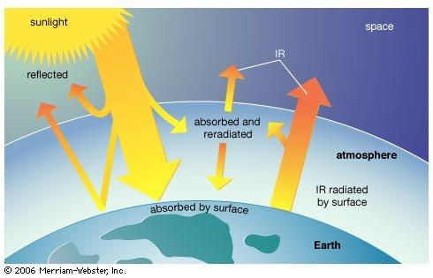

From 1,7⋅10⁵ TW of sunlight energy striking earth, it is estimated that 600TW could potentially been exploited. Hence, with solar cells of solely 10% efficiency, 60TW could be produced (Hagfeldt et al. 2010), enough energy for human needs. Significantly, the recent years there is a growing tendency for energy solar systems as well as efforts for increasing their efficiency.

- That means it is enough energy for human needs.

- Consequently, the recent years there is a growing tendency for energy solar systems as well as efforts for increasing their efficiency.

2) What examples/applicability can you name about using solar cells today? Give some examples from your daily life.

Part B

3) What are the most common photovoltaic systems used today? What materials do they use?


photo: https://commons.wikimedia.org/wiki/File:SolarCellPanel.jpg

4) What are semiconductors? Can you name some semiconductors?

Semiconductors are elements/compounds that their electrical conductivity is less that conductors and more that insulators. Contrasting metals in which resistance rises when temperature rises, semiconductors’ resistance falls while increasing temperature, since band gap between valence band and conduction band is comparable to room temperature values. Most common semiconductors are Silicon (₁₄Si), Germanium (₃₂Ge).

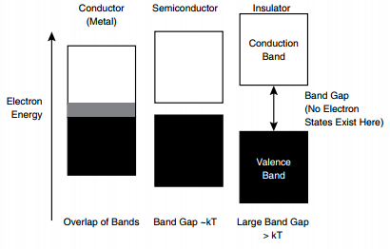
Image: Stevens et al. (2009)

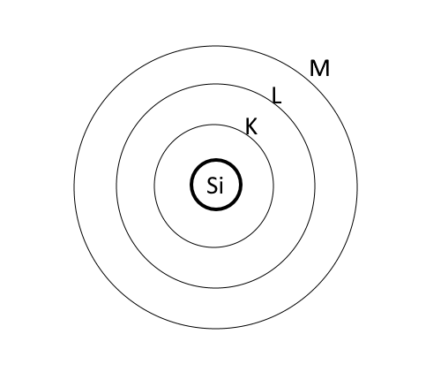
5) What is the electron contribution in each electron shell for the atom of Si?
K….. L….. M…..

6) Try to represent the structure of a crystalline lattice of Si.

7) What kind of bonds exist between Si atoms?

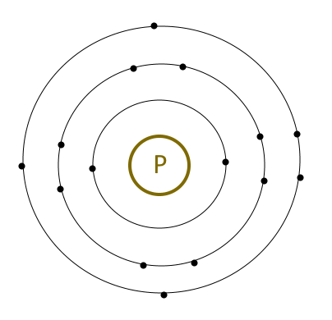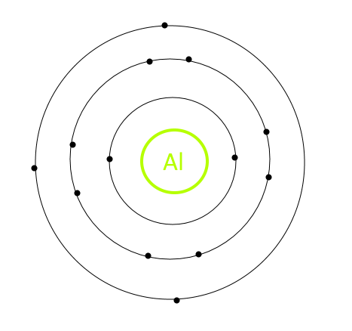

8) What change will occur if we implement some impurities of ₁₅P in the semiconductor?

9) What change will occur if we implement some impurities of ₁₃Al in the semiconductor?

This process of adding impurities with 5 or 3 electrons is called n-type doping and p-type doping, respectively.

10) What effect do you think doping will have on electrical conductivity?

11) Can you draw in the picture below what will happen if we combine a p-type semiconductor (“holes”) with an n-type semiconductor (free electrons)? Use drawing tools to represent and discuss your ideas.



Hence, a voltage and an electric field is been formed, as shown below:
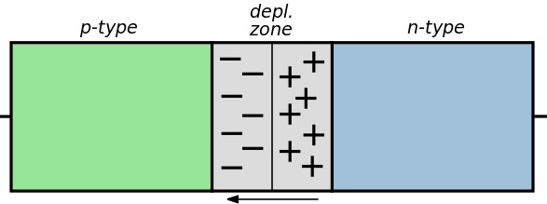

12) According to the previous discussion about energy bands in semiconductors, what do you expect to happen when light is absorbed from semiconductors a) in the p-type region, b) in the n-type region, c) in the depletion region?

Energy absorption from sunlight can create pairs of electrons-holes in the depletion region that separate due to the electrical field in the depletion region. Hence, electrical current is created. This is the basic operational principle of solar cells.
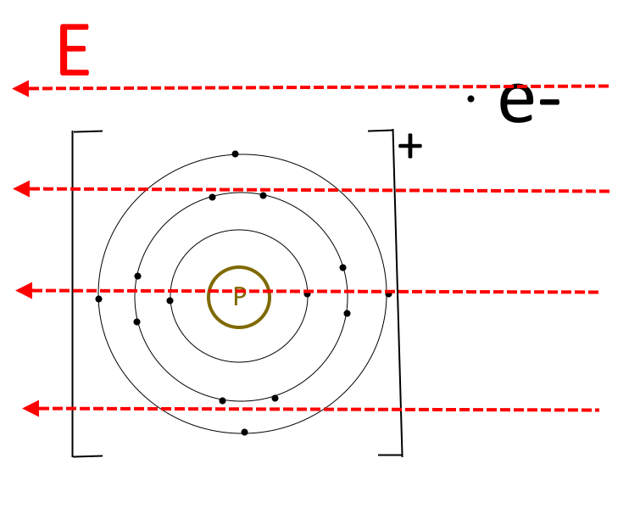

First-generation solar cells are made of p-n doped Silicon wafers and usually reach an efficiency of 15-20% (Figure a). Similarly, second-generation solar cells are made from thin film technology with amorphous Silicon and have an efficiency 10-15% (Figure b). However, despite their lower weight and cost reduction, second-generation solar cells face problems with the module stability (Pathakoti et al. 2018). In both cases, typical solar cells’ thickness is ranged from a fraction of micrometers to several micrometers (McEvoy et al. 2012).
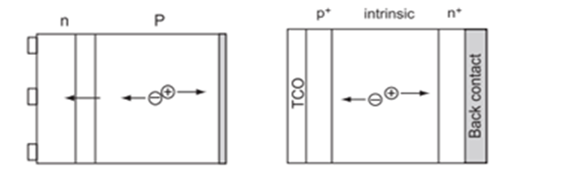
Images: McEvoy et al. 2012

a) crystalline Silicon solar cell b) single junction amorphous solar cell (McEvoy et al. 2012)

Watch the video illustration of pn type semiconductors below and discuss with your colleagues about operational principles of solar cells.
https://www.youtube.com/watch?v=L_q6LRgKpTw&t=81s

Think and discuss:

13) What do you think that are the main affordances that conventional (Silicon-based) solar cells have?

14) What do you think that are the main deficiencies/problems that conventional (Silicon-based) solar cells have?

Even though energy production through sunlight could be a green renewable alternative solution, in comparison with sources like coal or nuclear, photovoltaics face many challenges before they can replace these conventional sources in global energy production (Reddy et al 2014). Some of these challenges are: the high toxicity of solar cells (Moskowitz & Fthenakis 1990), high initial installation costs (Cañizo, Coso & Sinke 2009) and the fact that solar power plants require more land than conventional power plants (Reddy et al 2014). Moreover, the fabrication process of Silicon solar cells requires hazardous materials for cleaning, and incorporates the risk of inhaling dust of Silicon by workers (Khan & Arsalan 2016).

Challenge: Build an energy-efficient & sustainable way of exploiting sunlight energy!

15) Can you brainstorm potential alternative solutions for solar cells?

16) What difficulties/challenges are to be addressed?

Part C1

17) What do you know about the natural mechanism of photosynthesis? Instead of a semiconductor, what is the substance that absorbs energy from light during photosynthesis?
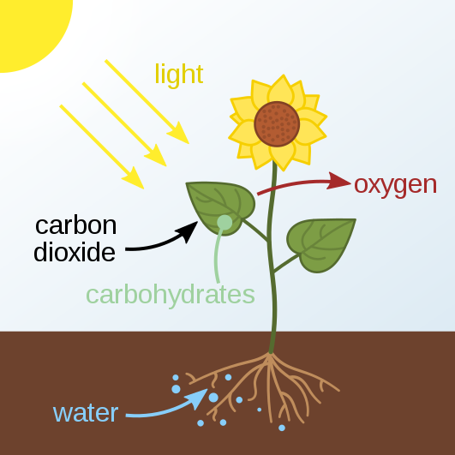
Image: https://commons.wikimedia.org/wiki/File:Photosynthesis_en.svg

18) How could this have affected the fabrication technology of solar cells? Could dye pigments be used for electrical energy production?

19) What advantages would such an approach have?

Watch the video below about the procedure of fabricating a Dye-Sensitised solar cell (Smestad & Grätzel 1998):
https://www.youtube.com/watch?v=8hertoGXWtE

20) Can you identify the role of each component in the DSSC solar cell?
a) dye molecules
b) mesoporous metal oxide layer (TiO₂)
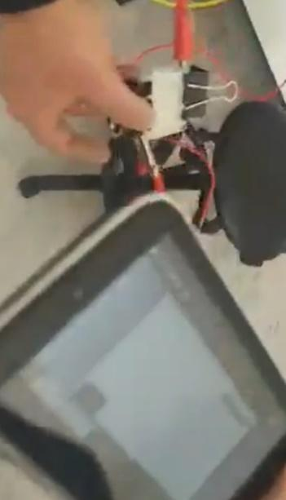
c) I⁻/I₃⁻ electrolyte
d) the transparent conducting oxides (Fluorine doped Tin Oxide (FTO) or Indium doped Tin Oxide (ITO)
e) platinum coated or graphite/graphene coated counter-electrode glass.

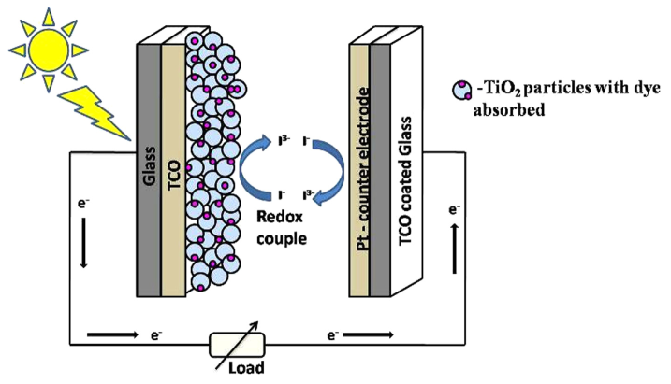

DSSC illustration (Salini et al. 2015)

Dye molecules absorb energy from light and excited electrons are injected in the conduction band of the mesoporous photoanode network (TiO₂).
Concurrently, I⁻ molecules replace the missing electrons in the dyes and are oxidized to I₃⁻. Electrons transmitted end to the counter electrode (Pt or graphite) and regenerate I⁻ in the cathode to complete the circuit.


21) What is the estimated output voltage that you can measure from your DSSC solar cell sample?

Watch the video titled video 1_ Supplemental material-Activity 2-DSS:
https://www.youtube.com/watch?v=nOsv95DBOCw&ab_channel=IdentitiesProject

22) What is the advancement that NST offers in the efficiency of DSSCs? What innovation can you think?

TiO₂ is relatively cheap, non-toxic and stable oxide material (Salini et al. 2015) and its bandgap is close to 3,2eV.
In summary there are many components in a DSSC and nanotechnology could play a vital role in improving its efficiency. Nanoparticles of TiO₂ used can increase the surface to volume ratio in which dye molecules can attach, hence increase the efficiency of the solar cell (Grätzel 2003). Moreover, by replacing the semiconductor by nanoparticles could enhance the light absorption by shifting the absorbtion egde from UV to IR (Kojima et al 2009) or 1-D nanostructures which allow higher electrical conductivity (e.g. Ebbesen et al 1996).

23) What advantages and what disadvantages do DSSC offer in relation to conventional solar cells?

The estimated performance of DSSCs is up to 11%. Low cost, and simple manufacturing process is among their benefits, whilst lacking stability is the drawback of the device. However, different architectures such as nanotubes instead of nanoparticles are quite promising in increasing their efficiency (Pathakoti et al. 2018).

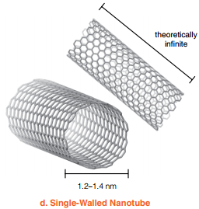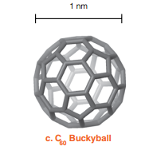

Images from Stevens et al. (2009). Images were created using MOLMOL (Koradi, Billeter and Withrich 1996). Coordinates for the buckyball image were obtained from www.nyu.edu/pages/mathmol/library. Coordinates for the carbon nanotube were generated at http://k.1asphost.com/tubeasp/tubeASP.asp.

24) What applicability could DSSCs have?

Part C2

25) Can you think of organic substances that could be used instead of semiconductors? What properties could we take advantage of? What advantages could such a technology have?

26) What applications could such a technology have?

27) Watch the video of a greenhouse artefact. Notice the properties of the organic solar cell attached to the roof. What do you observe about its usability?
(https://www.youtube.com/watch?v=WFtn7gUq2Ks&ab_channel=IdentitiesProject)
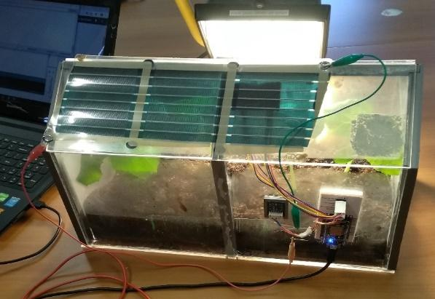

28) What do you result considering its output voltage?
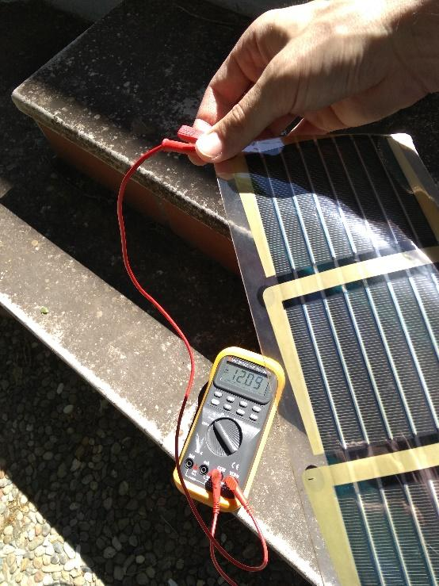

Organic semiconductors are Carbon-based, in which atoms in the molecule are bonded with conjugated π bonds, and molecules with weak van der Waals forces. This results on flexibility, light weight, and low sublimation points which allows easy processing.

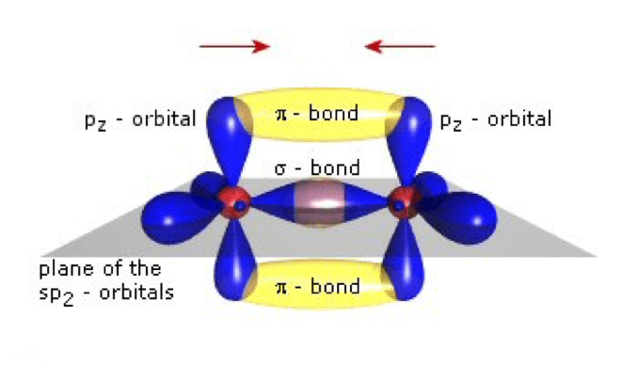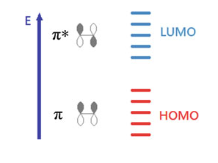
Image: materean.com Image: Fung & Choy 2012

In this case, the energy states of bonding-antibonding of the p orbital electrons are analogous to the valence-conduction band states in the classical semiconductors.

Due to the low cost of organic semiconductors, this technology is more suitable for large-scale power generation (Pathakoti et al. 2018). Furthermore, organic solar cells do not include liquids like DSSC that need protection from air, whilst their flexibility can result to limited space requirement (eg roll & roll setting)

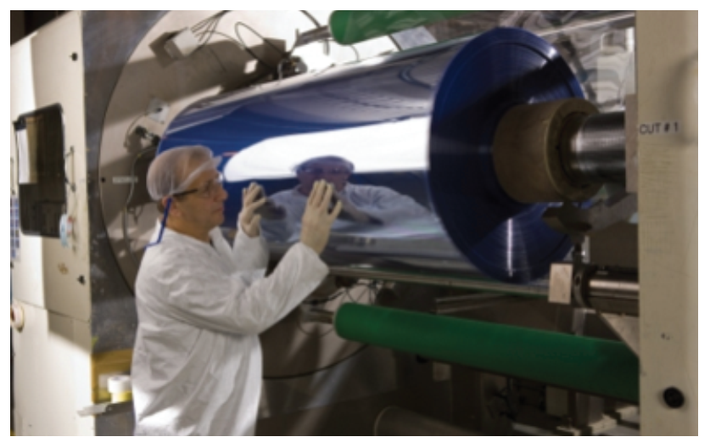
(https://www.elke.teicrete.gr/LinkClick.aspx?fileticket=M_PN6BSc9QY%3D&tabid=670)

Moreover. high coefficients of absorption of organic materials makes even a few hundreds of nanometers of the active layer thick enough to absorb an adequate amount of light and show significant solar cell characteristics.
However, the large bandgap between the two energy states (1,1eV) results on not absorbing low energy photons (low frequencies) and therefore, limiting absorbance to only 77% of sunlight energy.
Therefore, the combination of two different organic materials with correctly aligned band levels can result to efficient solar cells (Fung & Choy 2012).

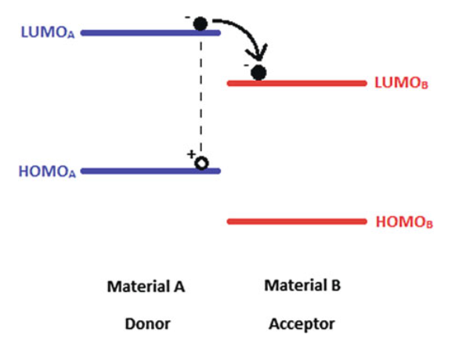
Image: Fung & Choy 2012

29) How could NST contribute to the efficiency of organic solar cells?

The challenge to be addressed in organic solar cells is that the exciton diffusion length, ie the distance that excitons can diffuse before recombination is a few tens of nanometers. On the other side, a very thin active layer may result in low absorption efficiency. Therefore, large interface area with adequate phase separation is needed. Nanostructured active layers, as well as carbon nanotubes, metal nanorods and fullerenes can assist the efficient transfer of electrons.

30) What other applicability could organic cells have?

31) How has NST contributed to third generation solar cells? What is the advancement that NST offers?

32) Compare your initial views on NST with the latter ones. What shifts, if any, do you recognise in using NST in solar cells?

Acknowledgement
Special thanks and appreciation to prof. Kymakis’ lab (HMU) and prof. Kyriakidis & Binas’ lab (FORTH) for the supply of organic solar cell and nanomaterials, respectively.

References
Cañizo, C., Coso, G. & Sinke, W., C. (2009). Crystalline Silicon Solar Module Technology: Towards the 1 s Per Watt-Peak Goal, Progress in photovoltaics research and applications, 17, 199-209
Cardona, M., & Peter, Y. Y. (2005). Fundamentals of semiconductors. Springer-Verlag Berlin Heidelberg.
Ebbesen, T., W., Lezec, H., J., Hiura, H., Bennet, J., W., Ghaemi, H., F. & Thio, T. (1996) Nature, 382, 54–56
Hagfeldt, A., Boschloo, G., Sun, L., Kloo, L., & Pettersson, H. (2010). Dye-sensitized solar cells. Chemical reviews, 110(11), 6595-6663.
Khan, J., & Arsalan, M. H. (2016). Solar power technologies for sustainable electricity generation–A review. Renewable and Sustainable Energy Reviews, 55, 414-425.
Kojima, A, Teshima, K, Shirai Y & Miyasaka, T. (2009) Organometal halide perovskites as visible-light sensitizers for photovoltaic cells, Journal of American Society, 131, 6050
Koradi, R., Billeter, M., and Wüthrich., K. (1996). MOLMOL: A program for display and analysis of macromolecular structures. Journal of Molecular Graphics 14, 51–55
McEvoy, A., Castaner, L., & Markvart, T. (2012). Solar cells: materials, manufacture and operation. Academic Press.
Moskowitz, P., D. & Fthenakis, V., M. (1990). Toxic materials released from photovoltaic modules during fires: Health risks, Solar Cells, 29(1), 63-71
Pathakoti, K., Manubolu, M., & Hwang, H. M. (2018). Nanotechnology applications for environmental industry. In Handbook of nanomaterials for industrial applications (pp. 894-907). Elsevier.
Reddy, K., G., Deepak, T., G., Anjusree, G., S., Thomas, S., Vadukumpully, S., Subramanian, K., R., V. (2014). On Global Energy Scenario, Dye-sensitized Solar Cells and the Promise of Nanotechnology, Physical Chemistry Chemical Physics, 16, 6838-6858
Shalini, S., Prasanna, S., Mallick, T. K., & Senthilarasu, S. (2015). Review on natural dye sensitized solar cells: operation, materials and methods. Renewable and Sustainable Energy Reviews, 51, 1306-1325.
Smestad, G. P., & Gratzel, M. (1998). Demonstrating electron transfer and nanotechnology: a natural dye-sensitized nanocrystalline energy converter. Journal of chemical education, 75(6), 752.
Stevens, S. Y., Sutherland, L. M., & Krajcik, J. S. (2009). The big ideas of nanoscale science and engineering. NSTA press.

